“IMPLEMENTATION OF ECCENTRIC NETWORK FOR INTRANET”

Carried out at

A Project Report submitted to the
JAWAHARLAL NEHRU TECHNOLOGICAL UNIVERSITY,
HYDERABAD

In partial fulfillment of the requirements
For the award of the degree of
BACHELOR OF TECHNOLOGY
In
INFORMATION TECHNOLOGY

Carried out by

Under the Guidance of

DEPARTMENT OF
INFORMATION TECHNOLOGY

CERTIFICATE

JAWAHARLAL NEHRU TECHNOLOGICAL UNIVERSITY
HYDERABAD

CERTIFICATE OF EXAMINERS

ACKNOWLEDGEMENTS

We manifest our heartier thankfulness pertaining to our contentment over Mrs. xxxxxxx, Department of Information Technology as a project guide with whose adroit concomitance the excellence has been exemplified in bringing out this project work with artistry. We express our gratitude to head of the department for the encouragement and assistance to us, which contribute to the successful completion of this project.
Involuntarily, we are perspicuous to divulge our sincere gratefulness to our principal, xxxxxxxxx , who has been observed posing valiance in abundance forwards our individuality to acknowledge our project work tendentiously.
We express our gratitude to xxxxxxx, Head of the department (IT). for the encouragement and assistance to us, which contribute to the successful completion of this project.
A heart full and sincere gratitude to our beloved parents for their tremendous motivation and moral support. We also express the over all exhilaration and gratitude to all those who animated our project work and accentuated our stance.

ABSTRACT

Eccentric network is mainly used in software companies. Because many persons involve in completion of the project like team leader, project leader. Team members should finish their daily task and their source code should be stored in the main server. This is the day-to-day task done by the team members.
Project leader assigns modules for the team members. These details are informed to the members manually. If the team member or the team leader is not in the office they can’t perform this task. So here we developed a private network for the team leader and the team member.
Using this network the project leader can assign the projects to the respective team members. Once the team member comes to work, they can come know the work assigned by checking offline. This information contains with the team member network id and password with project name and the roll of the project and time duration of the projects.
Once any team member got the project assignment mail they can interact with our private network and they do their daily task at any time. Here the project leader and project team member have their individual section for their processing. Using the admin section the project leader can assign the projects.
Users can interact with the network through user section. Here they can view all the files and folders, which are uploaded by them. If they have the permission to delete the file it can be done remotely

CONTENTS

CHAPTER-1 PREAMBLE Page No

  - General Introduction 01
  - Statement of the Problem 01
  - Objectives of the study 01
  - Scope of the study 02
  - Limitations of the study 02
  - Review of Literature 02
  - Methodology 03

CHAPTER-2 PROJECT PROGRAMMING
  - ASP.NET 09
  - C# 16

CHAPTER-3 SYSTEM ANALYSIS
  - Analysis Principles 26
  - Information Domain 26
  - Modeling 27
  - Functional Model 35
  - System Requirement 39
  - Hardware Requirement 39

CHAPTER-4 SYSTEM DESIGN
  - Data Design 40
  - Architectural Design 40
  - Interface Design 42
  - Procedural Design 42
CHAPTER-5 INTERPRETATION OF RESULTS
5.1 Testing 45
5.2 Testing Methods 46
CHAPTER-6 CONCLUSION 47
CHAPTER-7 ANNEXURES 48
CHAPTER-8 BIBLIOGRAPHY 60

CHAPTER 1

PREAMBLE

1.1 General Introduction:
This eccentric network is developing a common interface for different sections of the development firm. This system provides help in managing different projects as well as the members associated with the work instant status of involvements of a person in the task. It provides all the available members to be part of the team and easy selection procedure to make them available when required. It also provides security to the confidential information. It reduces the redundancy of making the entries of the activities, which are done manually. It speeds up the processing with firm. . 1.2 Statement of the Problem:
The current system is manual one where in the company the project leader intimates the day-to-day task. And the communication and event news over the work group is also manual. If the project leader is not present then the total work is attenuated. It needs to be loss for the company.
Due to this problem here we develop separate network for the organization employees will communicate by means of offline messages and they share documents.
1.3 Objective of the study
- The information of the entire firm will be maintained at a centralized data base any changes made by the other departments instantly.
- Provide Interactive interface through which a user can interact with different areas of application easily.
- Deploy the application on a single system and make is available on all the systems with in the network, there by reducing the maintenance cost of software.

1.4 Scope of the study
- Although the current system is confined to only one organization its performance is limited and restricted to the company. It spans over the Internet and can reach the server from their systems through intranet.
- The application is made as simple as surfing a website. There by non-technical persons can also interact with the processing on the application easily.
- Provides instant information regarding the work under process with in the company.
- The information regarding the project will be maintained at a main server any changes made by the project members are known to the project leaders instantly.
1.5 Limitations of the study
- If there is any problem in the LAN in organization then we cannot get appropriate information of the status of the system.
- Multiple messages cannot send directly at a time.
  - Review of Literature
Keeping in view the above problem, apart from the standard literature from various textbooks and websites were referred to understand the various steps involved in the process of development of the project.
Information regarding our project was searched. And the information about Net framework has been referred from various websites.
All the above literature was found to be more informative in the development of this project.
1.7 Methodology
Microsoft .NET Framework
The .NET Framework is a new computing platform that simplifies application development in the highly distributed environment of the Internet. The .NET Framework is designed to fulfill the following objectives:
- To provide a consistent object-oriented programming environment whether object code is stored and executed locally, executed locally but Internet-distributed, or executed remotely.
- To provide a code-execution environment that minimizes software deployment and versioning conflicts.
- To provide a code-execution environment that guarantees safe execution of code, including code created by an unknown or semi-trusted third party.
- To provide a code-execution environment that eliminates the performance problems of scripted or interpreted environments.
- To make the developer experience consistent across widely varying types of applications, such as Windows-based applications and Web-based applications.
- To build all communication on industry standards to ensure that code based on the .NET Framework can integrate with any other code.
The .NET Framework has two main components: the common language runtime and the .NET Framework class library. The common language runtime is the foundation of the .NET Framework. You can think of the runtime as an agent that manages code at execution time, providing core services such as memory management, thread management, and remoting, while also enforcing strict type safety and other forms of code accuracy that ensure security and robustness. In fact, the concept of code management is a fundamental principle of the runtime. Code that targets the runtime is known as managed code, while code that does not target the runtime is known as unmanaged code. The class library, the other main component of the .NET Framework, is a comprehensive, object-oriented collection of reusable types that you can use to develop applications ranging from traditional command-line or graphical user interface (GUI) applications to applications based on the latest innovations provided by ASP.NET, such as Web Forms and XML Web services.
The .NET Framework can be hosted by unmanaged components that load the common language runtime into their processes and initiate the execution of managed code, thereby creating a software environment that can exploit both managed and unmanaged features. The .NET Framework not only provides several runtime hosts, but also supports the development of third-party runtime hosts.
For example, ASP.NET hosts the runtime to provide a scalable, server-side environment for managed code. ASP.NET works directly with the runtime to enable Web Forms applications and XML Web services, both of which are discussed later in this topic.
Internet Explorer is an example of an unmanaged application that hosts the runtime (in the form of a MIME type extension). Using Internet Explorer to host the runtime enables you to embed managed components or Windows Forms controls in HTML documents. Hosting the runtime in this way makes managed mobile code (similar to Microsoft® ActiveX® controls) possible, but with significant improvements that only managed code can offer, such as semi-trusted execution and secure isolated file storage.
The following illustration shows the relationship of the common language runtime and the class library to your applications and to the overall system. The illustration also shows how managed code operates within a larger architecture.

Features of the Common Language Runtime
The common language runtime manages memory, thread execution, code execution, code safety verification, compilation, and other system services. These features are intrinsic to the managed code that runs on the common language runtime.
With regards to security, managed components are awarded varying degrees of trust, depending on a number of factors that include their origin (such as the Internet, enterprise network, or local computer). This means that a managed component might or might not be able to perform file-access operations, registry-access operations, or other sensitive functions, even if it is being used in the same active application.
The runtime enforces code access security. For example, users can trust that an executable embedded in a Web page can play an animation on screen or sing a song, but cannot access their personal data, file system, or network. The security features of the runtime thus enable legitimate Internet-deployed software to be exceptionally feature rich.
The runtime also enforces code robustness by implementing a strict type- and code-verification infrastructure called the common type system (CTS). The CTS ensures that all managed code is self-describing. The various Microsoft and third-party language compilers generate managed code that conforms to the CTS. This means that managed code can consume other managed types and instances, while strictly enforcing type fidelity and type safety.
In addition, the managed environment of the runtime eliminates many common software issues. For example, the runtime automatically handles object layout and manages references to objects, releasing them when they are no longer being used. This automatic memory management resolves the two most common application errors, memory leaks and invalid memory references.
The runtime also accelerates developer productivity. For example, programmers can write applications in their development language of choice, yet take full advantage of the runtime, the class library, and components written in other languages by other developers. Any compiler vendor who chooses to target the runtime can do so. Language compilers that target the .NET Framework make the features of the .NET Framework available to existing code written in that language, greatly easing the migration process for existing applications.
While the runtime is designed for the software of the future, it also supports software of today and yesterday. Interoperability between managed and unmanaged code enables developers to continue to use necessary COM components and DLLs. The runtime is designed to enhance performance. Although the common language runtime provides many standard runtime services, managed code is never interpreted. A feature called just-in-time (JIT) compiling enables all managed code to run in the native machine language of the system on which it is executing. Meanwhile, the memory manager removes the possibilities of fragmented memory and increases memory locality-of-reference to further increase performance finally, the runtime can be hosted by high-performance, server-side applications, such as Microsoft® MS Access™ and Internet Information Services (IIS). This infrastructure enables you to use managed code to write your business logic, while still enjoying the superior performance of the industry's best enterprise servers that support runtime hosting.NET Framework Class Library
The .NET Framework class library is a collection of reusable types that tightly integrate with the common language runtime. The class library is object oriented, providing types from which your own managed code can derive functionality. This not only makes the .NET Framework types easy to use, but also reduces the time associated with learning new features of the .NET Framework. In addition, third-party components can integrate seamlessly with classes in the .NET Framework.
For example, the .NET Framework collection classes implement a set of interfaces that you can use to develop your own collection classes. Your collection classes will blend seamlessly with the classes in the .NET Framework
As you would expect from an object-oriented class library, the .NET Framework types enable you to accomplish a range of common programming tasks, including tasks such as string management, data collection, database connectivity, and file access. In addition to these common tasks, the class library includes types that support a variety of specialized development scenarios. For example, you can use the .NET Framework to develop the following types of applications and services:

- Console applications.
- Scripted or hosted applications.
- Windows GUI applications (Windows Forms).
- ASP.NET applications.
- XML Web services.
- Windows services.
For example, the Windows Forms classes are a comprehensive set of reusable types that vastly simplify Windows GUI development. If you write an ASP.NET Web Form application, you can use the Web Forms classes.

CHAPTER-2
PROJECT PROGRAMMING

2.1 ASP.Net
Server Application Development
Server-side applications in the managed world are implemented through runtime hosts. Unmanaged applications host the common language runtime, which allows your custom managed code to control the behavior of the server. This model provides you with all the features of the common language runtime and class library while gaining the performance and scalability of the host server.
The following illustration shows a basic network schema with managed code running in different server environments. Servers such as IIS and MS Access can perform standard operations while your application logic executes through the managed code.
Server-side managed code
ASP.NET is the hosting environment that enables developers to use the .NET Framework to target Web-based applications. However, ASP.NET is more than just a runtime host; it is a complete architecture for developing Web sites and Internet-distributed objects using managed code. Both Web Forms and XML Web services use IIS and ASP.NET as the publishing mechanism for applications, and both have a collection of supporting classes in the .NET Framework.
XML Web services, an important evolution in Web-based technology, are distributed, server-side application components similar to common Web sites. However, unlike Web-based applications, XML Web services components have no UI and are not targeted for browsers such as Internet Explorer and Netscape Navigator. Instead, XML Web services consist of reusable software components designed to be consumed by other applications, such as traditional client applications, Web-based applications, or even other XML Web services. As a result, XML Web services technology is rapidly moving application development and deployment into the highly distributed environment of the Internet.
If you have used earlier versions of ASP technology, you will immediately notice the improvements that ASP.NET and Web Forms offers. For example, you can develop Web Forms pages in any language that supports the .NET Framework. In addition, your code no longer needs to share the same file with your HTTP text (although it can continue to do so if you prefer). Web Forms pages execute in native machine language because, like any other managed application, they take full advantage of the runtime. In contrast, unmanaged ASP pages are always scripted and interpreted. ASP.NET pages are faster, more functional, and easier to develop than unmanaged ASP pages because they interact with the runtime like any managed application.
The .NET Framework also provides a collection of classes and tools to aid in development and consumption of XML Web services applications. XML Web services are built on standards such as SOAP (a remote procedure-call protocol), XML (an extensible data format), and WSDL (the Web Services Description Language). The .NET Framework is built on these standards to promote interoperability with non-Microsoft solutions.
For example, the Web Services Description Language tool included with the .NET Framework SDK can query an XML Web service published on the Web, parse its WSDL description, and produce C# or Visual Basic source code that your application can use to become a client of the XML Web service. The source code can create classes derived from classes in the class library that handle all the underlying communication using SOAP and XML parsing. Although you can use the class library to consume XML Web services directly, the Web Services Description Language tool and the other tools contained in the SDK facilitate your development efforts with the .NET Framework.
If you develop and publish your own XML Web service, the .NET Framework provides a set of classes that conform to all the underlying communication standards, such as SOAP, WSDL, and XML. Using those classes enables you to focus on the logic of your service, without concerning yourself with the communications infrastructure required by distributed software development. Finally, like Web Forms pages in the managed environment, your XML Web service will run with the speed of native machine language using the scalable communication of IIS.
Active Server Pages.NET
ASP.NET is a programming framework built on the common language runtime that can be used on a server to build powerful Web applications. ASP.NET offers several important advantages over previous Web development models:
- Enhanced Performance. ASP.NET is compiled common language runtime code running on the server. Unlike its interpreted predecessors, ASP.NET can take advantage of early binding, just-in-time compilation, native optimization, and caching services right out of the box. This amounts to dramatically better performance before you ever write a line of code.
- World-Class Tool Support. The ASP.NET framework is complemented by a rich toolbox and designer in the Visual Studio integrated development environment. WYSIWYG editing, drag-and-drop server controls, and automatic deployment are just a few of the features this powerful tool provides.
- Power and Flexibility. Because ASP.NET is based on the common language runtime, the power and flexibility of that entire platform is available to Web application developers. The .NET Framework class library, Messaging, and Data Access solutions are all seamlessly accessible from the Web. ASP.NET is also language-independent, so you can choose the language that best applies to your application or partition your application across many languages. Further, common language runtime interoperability guarantees that your existing investment in COM-based development is preserved when migrating to ASP.NET.
- Simplicity. ASP.NET makes it easy to perform common tasks, from simple form submission and client authentication to deployment and site configuration. For example, the ASP.NET page framework allows you to build user interfaces that cleanly separate application logic from presentation code and to handle events in a simple, Visual Basic - like forms processing model. Additionally, the common language runtime simplifies development, with managed code services such as automatic reference counting and garbage collection.
- Manageability. ASP.NET employs a text-based, hierarchical configuration system, which simplifies applying settings to your server environment and Web applications. Because configuration information is stored as plain text, new settings may be applied without the aid of local administration tools. This "zero local administration" philosophy extends to deploying ASP.NET Framework applications as well. An ASP.NET Framework application is deployed to a server simply by copying the necessary files to the server. No server restart is required, even to deploy or replace running compiled code.
- Scalability and Availability.
ASP.NET has been designed with scalability in mind, with features specifically tailored to improve performance in clustered and multiprocessor environments. Further, processes are closely monitored and managed by the ASP.NET runtime, so that if one misbehaves (leaks, deadlocks), a new process can be created in its place, which helps keep your application constantly available to handle requests.
- Customizability and Extensibility.
ASP.NET delivers a well-factored architecture that allows developers to "plug-in" their code at the appropriate level. In fact, it is possible to extend or replace any subcomponent of the ASP.NET runtime with your own custom-written component. Implementing custom authentication or state services has never been easier.
- Security.
With built in Windows authentication and per-application configuration, you can be assured that your applications are secure.

Language Support
The Microsoft .NET Platform currently offers built-in support for three languages: C#, Visual Basic, and JScript.

What is ASP.NET Web Forms?
The ASP.NET Web Forms page framework is a scalable common language runtime programming model that can be used on the server to dynamically generate Web pages.
Intended as a logical evolution of ASP (ASP.NET provides syntax compatibility with existing pages), the ASP.NET Web Forms framework has been specifically designed to address a number of key deficiencies in the previous model. In particular, it provides:
- The ability to create and use reusable UI controls that can encapsulate common functionality and thus reduce the amount of code that a page developer has to write.
- The ability for developers to cleanly structure their page logic in an orderly fashion (not "spaghetti code").
- The ability for development tools to provide strong WYSIWYG design support for pages (existing ASP code is opaque to tools).
ASP.NET Web Forms pages are text files with an .aspx file name extension. They can be deployed throughout an IIS virtual root directory tree. When a browser client requests .aspx resources, the ASP.NET runtime parses and compiles the target file into a .NET Framework class. This class can then be used to dynamically process incoming requests. (Note that the .aspx file is compiled only the first time it is accessed; the compiled type instance is then reused across multiple requests).
An ASP.NET page can be created simply by taking an existing HTML file and changing its file name extension to .aspx (no modification of code is required). For example, the following sample demonstrates a simple HTML page that collects a user's name and category preference and then performs a form post back to the originating page when a button is clicked:
ASP.NET provides syntax compatibility with existing ASP pages. This includes support for <% %> code render blocks that can be intermixed with HTML content within an .aspx file. These code blocks execute in a top-down manner at page render time.
Introduction to ASP.NET Server Controls
In addition to (or instead of) using <% %> code blocks to program dynamic content, ASP.NET page developers can use ASP.NET server controls to program Web pages. Server controls are declared within an .aspx file using custom tags or intrinsic HTML tags that contain a runat="server" attributes value. Intrinsic HTML tags are handled by one of the controls in the System.Web.UI.HtmlControls namespace
Server controls automatically maintain any client-entered values between round trips to the server. This control state is not stored on the server (it is instead stored within an <input type="hidden"> form field that is round-tripped between requests). Note also that no client-side script is required.
In addition to supporting standard HTML input controls, ASP.NET enables developers to utilize richer custom controls on their pages. For example, the following sample demonstrates how the <asp: adrotator> control can be used to dynamically display rotating ads on a page.
- ASP.NET Web Forms provide an easy and powerful way to build dynamic Web UI.
- ASP.NET Web Forms pages can target any browser client (there are no script library or cookie requirements).
- ASP.NET Web Forms pages provide syntax compatibility with existing ASP pages.
- ASP.NET server controls provide an easy way to encapsulate common functionality.
- ASP.NET ships with 45 built-in server controls. Developers can also use controls built by third parties.
- ASP.NET server controls can automatically project both up level and down-level HTML.
- ASP.NET templates provide an easy way to customize the look and feel of list server controls.
- ASP.NET validation controls provide an easy way to do declarative client or server data validation.
2.2 C#.NET

ADO.NET OVERVIEW
ADO.NET is an evolution of the ADO data access model that directly addresses user requirements for developing scalable applications. It was designed specifically for the web with scalability, statelessness, and XML in mind.
ADO.NET uses some ADO objects, such as the Connection and Command objects, and also introduces new objects. Key new ADO.NET objects include the Dataset, Data Reader, and Data Adapter.

The important distinction between this evolved stage of ADO.NET and previous data architectures is that there exists an object -- the Dataset -- that is separate and distinct from any data stores. Because of that, the Dataset functions as a standalone entity. You can think of the Dataset as an always disconnected record set that knows nothing about the source or destination of the data it contains. Inside a Dataset, much like in a database, there are tables, columns, relationships, constraints, views, and so forth.

A Data Adapter is the object that connects to the database to fill the DataSet. Then, it connects back to the database to update the data there, based on operations performed while the Dataset held the data. In the past, data processing has been primarily connection-based. Now, in an effort to make multi-tiered apps more efficient, data processing is turning to a message-based approach that revolves around chunks of information. At the center of this approach is the Data Adapter, which provides a bridge to retrieve and save data between a Dataset and its source data store. It accomplishes this by means of requests to the appropriate SQL commands made against the data store.
The XML-based Dataset object provides a consistent programming model that works with all models of data storage: flat, relational, and hierarchical. It does this by having no 'knowledge' of the source of its data, and by representing the data that it holds as collections and data types. No matter what the source of the data within the Dataset is, it is manipulated through the same set of standard APIs exposed through the Dataset and its subordinate objects.
While the Dataset has no knowledge of the source of its data, the managed provider has detailed and specific information. The role of the managed provider is to connect, fill, and persist the Dataset to and from data stores. The OLE DB and SQL Server .NET Data Providers (System.Data.OleDb and System.Data.SqlClient) that are part of the .Net Framework provide four basic objects: the Command, Connection, DataReader and Data Adapter. In the remaining sections of this document, we'll walk through each part of the Dataset and the OLE DB/SQL Server .NET Data Providers explaining what they are, and how to program against them.
The following sections will introduce you to some objects that have evolved, and some that are new. These objects are:
- Connections: For connection to and managing transactions against a database.
- Commands: For issuing SQL commands against a database.
- DataReaders: For reading a forward-only stream of data records from a SQL Server data source.
- Datasets: For storing, Remoting and programming against flat data, XML data and relational data.
- DataAdapters: For pushing data into a DataSet, and reconciling data against a database.
When dealing with connections to a database, there are two different options: SQL Server .NET Data Provider (System.Data.SqlClient) and OLE DB .NET Data Provider (System.Data.OleDb). In these samples we will use the SQL Server .NET Data Provider. These are written to talk directly to Microsoft SQL Server. The OLE DB .NET Data Provider is used to talk to any OLE DB provider (as it uses OLE DB underneath).
Connections:
Connections are used to 'talk to' databases, and are represented by provider-specific classes such as SqlConnection. Commands travel over connections and result sets are returned in the form of streams which can be read by a DataReader object, or pushed into a DataSet object.

Commands:
Commands contain the information that is submitted to a database, and are represented by provider-specific classes such as SqlCommand. A command can be a stored procedure call, an UPDATE statement, or a statement that returns results. You can also use input and output parameters, and return values as part of your command syntax. The example below shows how to issue an INSERT statement against the Northwind database.
Data Readers:
The DataReader object is somewhat synonymous with a read-only/forward-only cursor over data. The DataReader API supports flat as well as hierarchical data. A DataReader object is returned after executing a command against a database. The format of the returned DataReader object is different from a recordset. For example, you might use the DataReader to show the results of a search list in a web page.
DATASETS AND DATA ADAPTERS:
Datasets
The Dataset object is similar to the ADO Record set object, but more powerful, and with one other important distinction: the Dataset is always disconnected. The Dataset object represents a cache of data, with database-like structures such as tables, columns, relationships, and constraints. However, though a Dataset can and does behave much like a database, it is important to remember that Dataset objects do not interact directly with databases, or other source data. This allows the developer to work with a programming model that is always consistent, regardless of where the source data resides. Data coming from a database, an XML file, from code, or user input can all be placed into Dataset objects. Then, as changes are made to the Dataset they can be tracked and verified before updating the source data. The Get Changes method of the Dataset object actually creates a second Dataset that contains only the changes to the data. This Dataset is then used by a Data Adapter (or other objects) to update the original data source.
The Dataset has many XML characteristics, including the ability to produce and consume XML data and XML schemas. XML schemas can be used to describe schemas interchanged via Web Services. In fact, a Dataset with a schema can actually be compiled for type safety and statement completion.
DATA ADAPTERS (OLEDB/SQL)
The DataAdapter object works as a bridge between the DataSet and the source data. Using the provider-specific SqlDataAdapter (along with its associated SqlCommand and SqlConnection) can increase overall performance when working with a Microsoft SQL Server databases. For other OLE DB-supported databases, you would use the OleDbDataAdapter object and its associated OleDbCommand and OleDbConnection objects.
The DataAdapter object uses commands to update the data source after changes have been made to the DataSet. Using the Fill method of the DataAdapter calls the SELECT command; using the Update method calls the INSERT, UPDATE or DELETE command for each changed row. You can explicitly set these commands in order to control the statements used at runtime to resolve changes, including the use of stored procedures. For ad-hoc scenarios, a Command Builder object can generate these at run-time based upon a select statement. However, this run-time generation requires an extra round-trip to the server in order to gather required metadata, so explicitly providing the INSERT, UPDATE, and DELETE commands at design time will result in better run-time

Performance
- ADO.NET is the next evolution of ADO for the .Net Framework.
- ADO.NET was created with n-Tier, statelessness and XML in the forefront. Two new objects, the DataSet and DataAdapter, are provided for these scenarios.
- ADO.NET can be used to get data from a stream, or to store data in a cache for updates.
- There is a lot more information about ADO.NET in the documentation.
- Remember, you can execute a command directly against the database in order to do inserts, updates, and deletes. You don't need to first put data into a DataSet in order to insert, update, or delete it.
- Also, you can use a DataSet to bind to the data, move through the data, and navigate data relationships
About SQL SERVER
The computer industry moves to more distributed environments and moves its data from mainframe to servers; you need to understand the concepts behind a client/server database environment.
In several respects, server databases such as Microsoft SQL Server are identical to mainframe databases. The overwhelming majority of databases used on computer systems are relational databases. Also, server databases such as relational databases on mainframe or minicomputer systems support the use of Structured Query Language (SQL), as well as proprietary tools for accessing data.

Making the Move to SQL Server
Two Key features of a server database become importing because of the client access to data. The first feature provides single point of access to the data in the database. The second feature device processing and manipulation between the client and server systems.
SQL Server permits client applications to control the information retrieve from the server by using several specialized tools and techniques, including options such as stored procedures server enforced roles and the triggers that permits processing to be done on the server automatically. You don’t have to move all processing to the server, of course; you still can do appropriate information processing on the client workstation .Perform the administration of the databases Control access to data in the databases Control the manipulation of data in the databases .You also can use a command line interface to perform all operations With SQL Server.
UNDERSTANDING RELATIONAL FEATURES OF SQL SERVER
A Key characteristic of SQL Server is that it is a Relational Database. We must understand the features of a Relational database to effectively understand and access data with SQL Server. We can not construct successful Queries to return data from a Relational Database unless we understand basic features of the Relational Database.
Dr.E.F.Codd designed the model for relational databases in 1970, as a means of storing, retrieving, and manipulating data more easily than in hierarchical and network databases. Hierarchical and network databases were difficult to design, and it sometimes was difficult to write proper queries for access to data.
Hierarchical and network databases were difficult to work with for several reasons. One reason was that the physical and logical definitions of data storage in hierarchical and network databases had to be written in a cryptic syntax.
Another difficulty of working with data definitions came from the fact that different types of internal pointers, numeric references to data locations, and other low-level details had to be set up and stored through the databases. The pointers were used for the subsequent direct retrieval of data.
In Cod’s relational database model, the data is referenced as though it were stored in a two-dimensional table. The actual physical storage of the data-although significant for the time required to store, change, or retrieve data-is insignificant syntactically for reference. The two-dimensional table model permits data to be referenced as the rows and columns of the table.
In a Relational Database, data is referenced as the rows and columns of a table. We can easily visualize data stored as a table, because we often encountered data stored in tables in every day life. We reference train and plane schedules as a table, for example and we create typical work sheets as a table.
EXPLORING CLIENT/SERVER FEATURES OF SQL SERVER
Client/Server computing is a type of distributed model for data storage, access, and processing. In a distributed processing system, multiple computers collectively perform a set of operations. A Client/Server system uses at least two computers, one of which nearly always is a personal computer.
Each system in a client/server model performs one or more of the data storage, access, or processing operations. Client/Server computing can not be done with a system that uses terminals or PC’s running terminal emulators that are connected to another computer. In this arrangement, the terminal are the PC that’s used as a terminals is simply too passive; it only sends and displays sets of characters. When PC’s and Servers are connected, the overall processing should be divided between the server, main frame, or mini computer system and the client system. The client and the server each process works with in its own capability. A form of team work that contributes to the efficiency and speed of the overall operation.
Client/Server as the name implies, also involves an unequal division of processing. The in equality results from the processing disparity between the server and the client. The larger and faster server computer transfers data faster, stores greater qualities of data, and typically performs more extensive processing than the client system.
Smaller PC Systems are used as Client in Client/Server systems because the PC’s perform proportionally less of the overall work, relaying primarily on the server for heavy duty data manipulation. Also , the PC’s key board and monitor allowed into work as an input device , by generating commands and data , and as on output device by displaying data to the user.
MS SQL Server is a perfect example of a Client/Server system. The SQL Server Database must be installed on the Windows NT platform. The Windows NT operating system provides an extremely broad range of processor systems that we can use as our server. Windows NT is supported on I86 Processor based systems, PPC, MIPS, and ALPHA AXP RISC Processor based systems.
SQL Server provides the server software that install on the server system and some client software that’s installed on the client PC systems Windows GUI application tools allow into create , maintain and access the database and all objects from the client.
The Network software components required for the inter connection of clients and server computer are built into the window’s NT system. Window’s NT also provides a choice of network protocols for communication between the client and the server systems. A Client can run windows ’95, which also contains built-in network software for connection with the Windows.NT server system. The Window’95 Client and Windows.NT server systems support a void range of network cards.
SQL SERVER FEATURES
The core components of SQL Server are the Relational Database and its structure. SQL Server is a power full, compressive database environment. This section points out certain parameters for using SQL Server.
SQL Server allows view to define up to 32,767 databases. If we realize that a database is a centralized repository for the storage of information, being overly constrained by the 32,767 database limit is difficult; we are not likely to encounter any situation in which we need to define more than these very liberal limit. If we do, consider adding servers to our net work to help balance the load. In a typical production installation, fewer than five application oriented databases are in service on any given server.

CHAPTER-3

SYSTEM ANALYSIS
It’s necessary to take a header look at software’s role-to understand the specific requirements that must be achieved to build high quality software. That’s the job of software requirement Analysis. Requirement analysis allows the job of the software allocation and builds models of the data, functional, and behavioral domains that will be treated by software.
It is a task that bridges the gap between system levels requirements engineering and software design. It provides the software designer with a representation of information, function, and behavior that can be translated to data, architectural, interface, and component-level designs. Finally, the requirement specification provides the developer and the customer with means to access quality once software is built.
3.1 Analysis Principles:
The analysis of the entire project lists the following goals to be achieved and the difficulties to be faced. The main purpose for doing this project is to give a general insight into the analysis and requirements of the existing system or situation and for determining the operating characteristics of the system. The information of the entire firm will be maintained at a centralized database any changes made by the other departs are known to the higher or lower departments instantly. Provide Interactive interface through which a user can interact with different areas of application easily
3.2 Information Domain:
Requirement analysis is a software-engineering task that bridges the gap between system level software allocation and software design. Requirement analysis enables the system engineer to specify software function and performance indicates software’s interface with other system elements and establish constraints that software must meet.
Requirement analysis provides the software designer with models that are translated in to data and procedural design. Software requirement analysis is a model building activity. Establishing a complete information description a detailed functional and behavioral description an indication of performance requirements and design constraints and other data pertinent to requirements refines the function and performance allocated to the system.
3.3 Modeling:
The tools that are used in software requirement analysis are
- Data flow diagrams and
- Data dictionary
Data Flow Diagram:
A data flow diagram is a logical model of a system. The data flow diagram is a graphical picture of the logical system, a data flow diagram is a graphic tool used to describe and analyze the movement of data through a system including the processes, stores of data and delays in system.
Data flow diagram is the central tool and the basis from which other components are developed the transformation of data from input to output through processes, may be described logically and independently of the physical components associated with the system.
DFD SYMBOLS:
In the DFD, there are four symbols
- A square defines a source(originator) or destination of system data
- An arrow identifies data flow. It is the pipeline through which the information flows
- A circle or a bubble represents a process that transforms incoming data flow into outgoing data flows.
- An open rectangle is a data store, data at rest or a temporary repository of data
Process that transforms data flow

Source or Destination of data

Data flow

Data Store

CONSTRUCTING A DFD:
Several rules of thumb are used in drawing DFD’s:
- Process should be named and numbered for an easy reference. Each name should be representative of the process.
- The direction of flow is from top to bottom and from left to right. Data traditionally flow from source to the destination although they may flow back to the source. One way to indicate this is to draw long flow line back to a source.
- An alternative way is to repeat the source symbol as a destination. Since it is used more than once in the DFD it is marked with a short diagonal.
- When a process is exploded into lower level details, they are numbered.
- The names of data stores and destinations are written in capital letters. Process and dataflow names have the first letter of each work capitalized
A DFD typically shows the minimum contents of data store. Each data store should contain all the data elements that flow in and out. Questionnaires should contain all the data elements that flow in and out. Missing interfaces redundancies and like is then accounted for often through interviews.

SAILENT FEATURES OF DFD’s

- The DFD shows flow of data, not of control loops and decision are controlled considerations do not appear on a DFD.
- The DFD does not indicate the time factor involved in any process whether the data flows take place daily, weekly, monthly or yearly.
- The sequence of events is not brought out on the DFD.

TYPES OF DATA FLOW DIAGRAMS
- Current Physical
- Current Logical
- New Logical
- New Physical

1. CURRENT PHYSICAL:
In Current Physical DFD process label include the name of people or their positions or the names of computer systems that might provide some of the overall system-processing label includes an identification of the technology used to process the data. Similarly data flows and data stores are often labels with the names of the actual physical media on hich data are stored such as file folders, computer files, business forms or computer tapes.
2. CURRENT LOGICAL:
The physical aspects at the system are removed as mush as possible so that the current system is reduced to its essence to the data and the processors that transform them regardless of actual physical form.
3. NEW LOGICAL:
This is exactly like a current logical model if the user were completely happy with he user were completely happy with the functionality of the current system but had problems with how it was implemented typically through the new logical model will differ from current logical model while having additional functions, absolute function removal and inefficient flows recognized.
4. NEW PHYSICAL:
The new physical represents only the physical implementation of the new system.

RULES GOVERNING THE DFD’S

PROCESS
- No process can have only outputs.
- No process can have only inputs. If an object has only inputs then it must be a sink.
- A process has a verb phrase label.

DATA STORE
- Data cannot move directly from one data store to another data store, a process must move data.
- Data cannot move directly from an outside source to a data store, a process, which receives, must move data from the source and place the data into data store
- A data store has a noun phrase label.

SOURCE OR SINK
The origin and /or destination of data
- Data cannot move direly from a source to sink it must be moved by a process
- A source and /or sink has a noun phrase land

DATA FLOW

- A Data Flow has only one direction of flow between symbols. It may flow in both directions between a process and a data store to show a read before an update. The later is usually indicated however by two separate arrows since these happen at different type.
- A join in DFD means that exactly the same data comes from any of two or more different processes data store or sink to a common location.
- A data flow cannot go directly back to the same process it leads. There must be at least one other process that handles the data flow produce some other data flow returns the original data into the beginning process.
- A Data flow to a data store means update (delete or change).
- A data Flow from a data store means retrieve or use.
A data flow has a noun phrase label more than one data flow noun phrase can appear on a single arrow as long as all of the flows on the same arrow move together as one package.

MODULE -1
User Interaction module

User
Interaction
Module

About login

Login

About Eccentric

Events

Achievements

Forgetting of
Password

Internal
Interaction
Module

Fig 3.1:- User Interaction Module

MODULE -2
Internal Interaction module
Admin

Internal Interaction module

Admin

Project
Leader

Project
Member

Compose

Work
Space

People
Finder

News

Sent Items

Inbox

Forms
Details
Of
User

About

Admini
Stration

Clients

Project

Project, Employee,
Clients

Project
Member

Compose

Fig 3.2 Internal Interaction Module

MODULE -2
Internal Interaction module
Project Leader

Project Leader

Compose

Work
Space

People
Finder

News

Sent Items

Inbox

Forms

Details
Of
User

About

Project

Fig 3.3:- Internal Interaction Module for Project Leader

Project Member

Compose

Work
Space
People
Finder

News

Sent Items

Inbox

Forms
Details
Of
User

About

Project
MODULE -2
Internal Interaction module
Project Member

Fig 3.4:- Internal Interaction Module for Project Member

MODULE -2
Internal Interaction module
Clients
Clients

Compose

Work
Space

News

Sent Items

Inbox

Forms
Details
Of
User

About

Project

Fig 3.3:- Internal Interaction Module for Project Clients

3.4 Functional Model:

The complete system can be divided into two halves on basis of access levels
A) User interaction module
B) Internal Interaction module
A) User Interaction Module:
In User Interaction module, User interact with home page controls
About Login:
It includes Username and Password, those who want to enter into the page
then click onto the login, we should go for another page
About:
Eccentric Network is mainly used in software companies. In this company day to day tasks are intimated by the project leader. And communication and event news over the work group is also manual.
Events:
The information regarding the project will be shared by each member and they completed their work within time. It provides instant information regarding work under5 process within the company.
Achievements:
Management interacts with private network and share their views and internal communication on the application of the organization. It should arrange conference over the processing information in order to reach destination.
Forgetting of Password:
If users forget the Password, then some hint will be provided for getting the password.
B) Internal Interaction Module:
The current system is the manual one where in the company, the customers should interact with administrator. Here external communication and the event news over the work group is also manual. It is much user friendly.
Administrator:
An administrator has all the privileges that of the guest as well as the normal registered user. Along with these common features an administrator has the administrator related features such as creating new users and granting roles to those newly created users. The roles granted by the administrator cannot be changes by the user. An administrator can create new user as a guest or as a user or as an administrator. The access levels are as per the grants done by the administrator.
An administrator can also be part of a team and could lead a project team this is possible only if administrator when building a team includes himself in the team section. If included as a manager he is not a part of the team but supervisor of the team.
The register option on the homepage of the application is provided only to register a new user as a guest.
PROJECT LEADER
Deliver Results:
Project results delivered on time, within budget. Implement change when and where needed with skilled project management.
Control performance:
Plan, estimate and schedule to control scope, performance and risk . Control the project explosion.

Solve Problems:
Challenges-solutions for tough problems-ready when needed – ‘just in time’ – tested and proven in the caldron of projects
Develop Leaders
Enable project leaders and project teams to achieve extraordinary results. Exceptional teamwork breeds success.
PROJECT MEMBERS
Being a great project member can aid the team process as much as a good team leader. Just as project members will have expectations of team leaders, they will also have expectations of other team members.
Here are some of the elements that make a great team member:
- Commitment to the team above themselves.
- Positive contribution to the team process and goals.
- Enthusiasm energy, inspiration and sufficient expertise.
- Willingness to take responsibility for elements of the team’s work.
If an individual is to be fully valued by team, they must be committed to the success of the team. If they agree to carryout action steps at team meetings, there is an expectation that these will be carried out, unless that expectation is changed. If at the following team meeting, the team is surprised by an individual not delivering on what they agreed, there is a danger that they will lose trust in the individual.

Clients:

Provide Clients:
- Provide necessary business information
- Ensure deliverables are prepared to satisfy the project requirements, cost and schedule.
- Help provide status reporting of team activities against the program plan or schedule keep the coordinates meetings with the product committee.
- The team is surprised by an individual not delivering on what they agreed, there is a danger that they will lose trust in the individual. It is better to resist the pressure to deliver initially and set appropriate expectations, than to say yes, and then spend the next weeks finding ways of apologizing.

ACCESS CONTROL FOR DATA WHICH REQUIRE USER AUTHENTICATION
The following commands specify access control identifiers and they are typically used to authorize and authenticate the user (command codes are Shown in parentheses)
USER NAME (USER)
- The user identification is that which is required by the server for access to its file system. This command will normally be the first command transmitted by the user after the control connections are made (some servers may require this).
PASSWORD (PASS)
- This command must be immediately preceded by the user name command, and, for some sites, completes the user's identification for access control. Since password information is quite sensitive, it is desirable in general to "mask" it or suppress type out.

Requirements
3.5 System Requirements
- Web-Technologies : ASP.NET
- Frameworks : .NET Framework 2.0
- Database : SQL Server 2005
- Web server : IIS 5.0
- Language : C#

3.6 Hardware Requirements
- Operating System : Windows XP Professional sp2
- Processor : Pentium 4.0(1.6GHz)
- Memory : 512 MB

CHAPTER 4

SYSTEM DESIGN

After completing the analysis of the project, we have clearly got the set of goals to be achieved. In the design phase we have to make an overall of structure of the project using the data collected from the analysis phase.
Design is a meaningful engineering representation of something that is to be built. Software design is located at the technical kernel of software engineering and is applied regardless of software process model that is used. It is first of the three technical activity designs, code generation and test. It focuses all four major areas of concern:
    - Data Design
    - Architectural Design
    - Interface Design
    - Code Design
4.1 DATA DESIGN
The Data design transforms the information domain model created during analysis into the data structures that will be required to implement the software.
4.2 ARCHITECTURAL DESIGN
The architectural design defines the relationship between major structural elements of the software, the "design patterns" and the "constraints".
Project Details

S .No | Column Name | Data Type | Description
1 | Project id | int
2 | Project name | nvarchar (50)
3 | Project status | nvarchar(50)
4 | Start date | smalldatetime
5 | Completion date | smalldatetime
6 | Client name | varchar(50)
7 | Client location | varchar(50)
8 | Project description | varchar(MAX)
9 | Id information | Varchar(50)

Forums

S .No | Column Name | Data Type | Description
1 | Subject | varchar(50)
2 | Username | varchar(50)
3 | Authority | Varchar(50)
4 | Message | ntext
5 | Date of post | datetime

Inbox

S .No | Column Name | Data Type | Description
1 | to1 | varchar(50)
2 | from1 | Varchar(50)
3 | subject | Varchar(50)
4 | message | Varchar (MAX)
5 | date | datetime

News

S .No | Column Name | Data Type | Description
1 | subject | varchar(50)
2 | username | varchar(50)
3 | authority | varchar(50)
4 | message | ntext
5 | dateofpost | char(10)

UserDetails

S.No | Column Name | Data Type | Description
1 | firstname | nchar(10)
2 | lastname | nchar(10)
3 | username | nvarchar(50)
4 | password | nvarchar(50)
5 | authority | nvarchar(50)
6 | phoneno | char(10)
7 | email | nvarchar(50)
8 | Dateofbirth | nchar(10)
9 | securityquestion | nvarchar(50)
10 | answer | nvarchar(50)
11 | location | nvarchar(50)

4.3 INTERFACE DESIGN
The interface design describes how the software communicates within itself, with systems that inter operate with it and with humans who .The component -level design transforms structural elements of the software architecture into a procedural description of software components.
Computer software is considerably more complex than a house; hence we need a blue print-like design .It is the place where quality is important in software engineering. Design is the only way that can accurately translate a customer's requirements into a finished software produce or system. Without design, we risk building an unstable system-one that will fail when small changes are made: one that may be difficult to test: one whose quality cannot be assessed until late in the software process.
A detailed design describes how a proposed information system will deliver. The general capabilities described preliminary design. The detailed design usually considers the following parts of the system in this order: Output requirement, Input requirement, storage requirement, processing requirement and system control and back-ups. Which can be described under the heading says, data design & code design.

4.4 PROCEDURAL DESIGN
The design phase focuses on the detailed implementation of the system. The design phase is a transition from a user-oriented document to a document oriented to
the programmers or data base personnel. System design is a process through which requirements are translated into a representation of software. Initially the representation depicts a holistic view of software. Subsequent refinement leads to a design representation that is very close to source code. Design is a place where quality fostered in software development. Design provides us with representations of software that can be assessed for quality; this is the only way that can accurately translate the user requirements into finished software product or system. System design serves as the foundation for all software engineering and software maintenance steps that follow. System design goes through two phases of development: logical and physical design.

Logical Design
This design describes the inputs, outputs, databases and procedures all in a format that meets the user’s requirements. Logical design specifies the user needs at a level of detail that virtually determines the information flow into and out of the system and the required data resources. The design covers the following:
- Input/Output specifications – This include screens, format and content.
- File specifications – This includes specifying rules for edit correction, backup procedures and the controls that ensure processing and file integrity.
- Processing specifications – This specifies the implementation plan.

Physical Design
Logical design is followed by physical design. This produces the working system by defining the design specifications that tell programmers exactly what the system must do. This produces the report on a hard copy or displays it on a screen, and maintains an updated database at all times. This design consists of following steps:
- Design physical system – This specifies input/output media, design of database and design of information flow.
- Plan system implementation – This specifies the target date. Determines training procedures and courses. Devise a test and implementation plan. This system has been designed with a scientific approach and ended developing an application, which can be used, and embed in ease and can utilize it for further developments and in applications where it is felt necessary.

CHAPTER 5

INTERPRETATION OF RESULTS

5.1 TESTING :
The completion of a system is achieved only after it has been thoroughly tested and implemented. Though this gives a feel the project is completed, there cannot be any project without going through this stage. Though the programmer may take many precautions not to commit any mistakes that crop up during the execution stage. Hence in this stage it is decided whether the project can under go the real time environment execution without any breakdowns, therefore a package can be rejected even this stage. In short this stage is meant to decide if the package is good for complete implementation.
5.2 TESTING METHODS:
Testing is a set of activities that can be planned in advance and conducted systematically. The proposed system is tested in parallel with the software that consists of its own phases of analysis, implementation, testing and maintenance. Following are the tests conducted on the system.
5.2.1 Unit Testing:
During the implementation of the system each module of the system was tested separately to uncover errors with in its boundaries. User interface was used as a guide in the process.
5.2.2 Functionality Testing:
To determine if the various display screens meet the design rules and functionality are complete and correct.
ROBUSTNESS:
To study the behavior of the module in case of feeding in the relevant data and ensure that the system is able to display appropriate message and role back to its initial state.

5.2.3 ACCEPTANCE TESTING:
Acceptance testing is done to verify for implementation and use. The proposed system provides the end-user confidence and ensures that the software is already to use.
5.2.4 Integration Testing:
The objective integration is to take unit tested modules and build a program that has been defined and designed. We have done a top down integration test which is an increment approach which constructs and tests small segments where errors to isolate and correct. Testing is very important aspect of software development process. In order to ensure that client and server are functioning properly, three different testing have been conducted.
They are as follows:
To extent possible, each class was tested separately. This similar to what could be called a unit testing. Of course not all classes could be tested separately.
1. Once several components have been created, and all of them together started testing. Even if any change to made only one class and tried it recompiled and tested available components at the same time.
2. Third type of testing is to check multithreaded functionality after all the modules are integrated than the system as whole is tested. Since a sever is multithread implementation, must function correctly with multiple use talking concurrently.

CHAPTER 6
CONCLUSION
SYSTEM EVALUATION:
The developed software is tested with sample data and outputs obtained in according to the requirements. The performance of the system is evaluated, and is found to be much more efficient than the existing system. Though it could not be claimed that ours is an ideal project, it will meet the primary requirements of the concern. Even though we have tried our level best to make it a dream project, due to time constraints we could not add more facilities to it. So the project has to be improved by having modifications as and when the necessity arises in due course.

FUTURE EXPANSIONS:
The efficiency of developed system can be much enhanced with some minor modifications. Further developments can be made in the proposed system by implementing the Eccentric Network for Intranet.
They are:
1. The application is capable of managing only projects and their respective allotments where as there is not scope of communication between two project groups or between the employees. The information between them is still in terms of documents. The application can improve in this area of communication and document preservation as well as client maintenance.
2. The application can be converted into a Mobile based using ASP.net with which the deployment of application will be done only on enterprises server and is accessible to all other departments of the organization. The current application is confined to only one enterprise.

CHAPTER 7

ANNEXURES

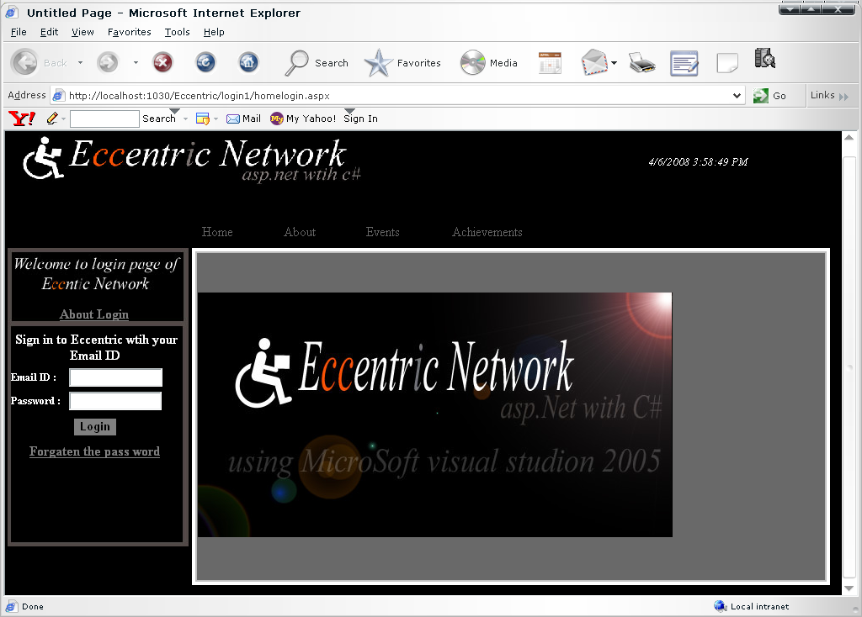

Fig(7.1):- This is the login form of the Eccentric Network

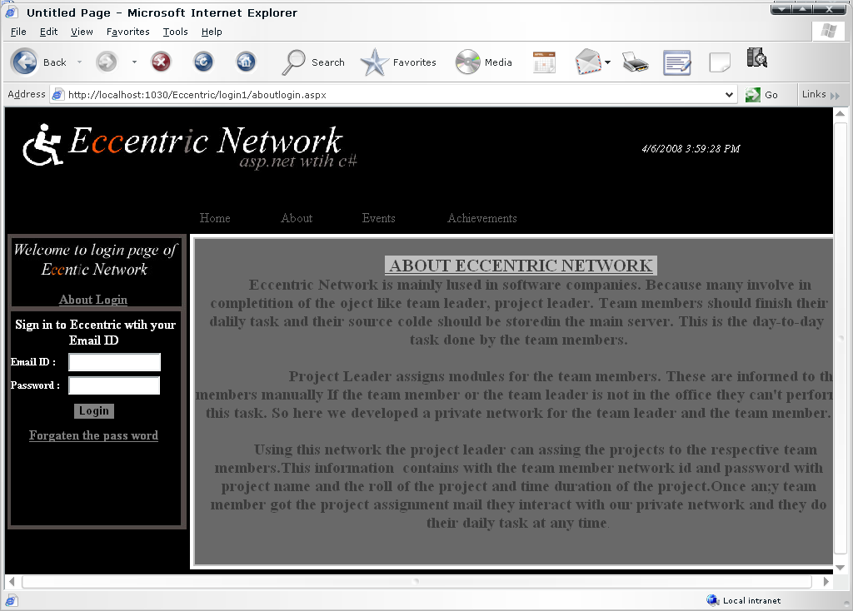
Fig(7.1.1):- It shows About Eccentric Network

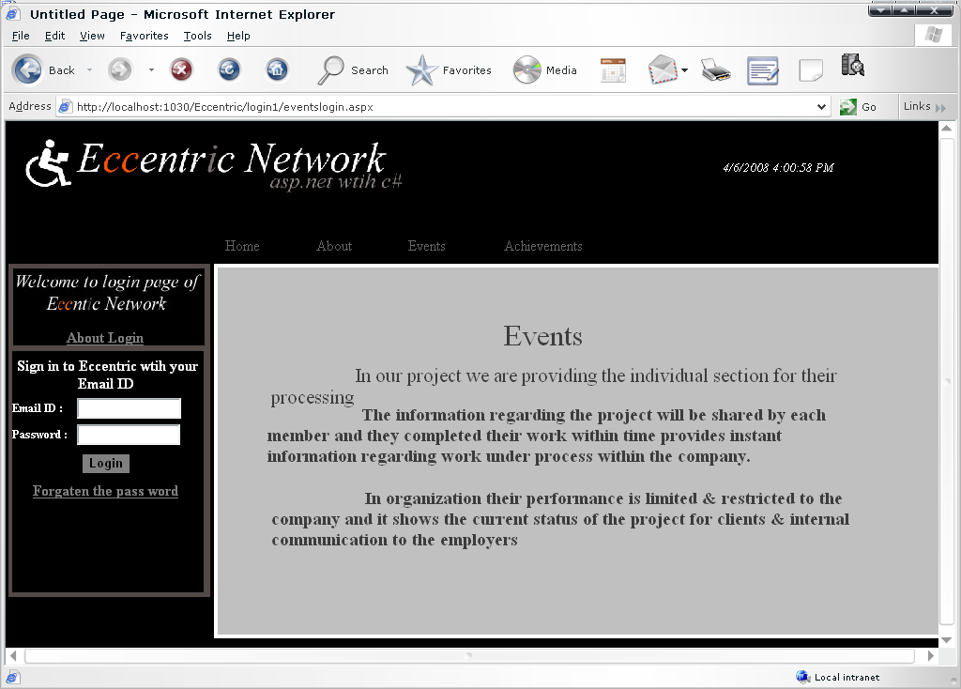

Fig(7.1.2):- It shows the Events of Eccentric Network

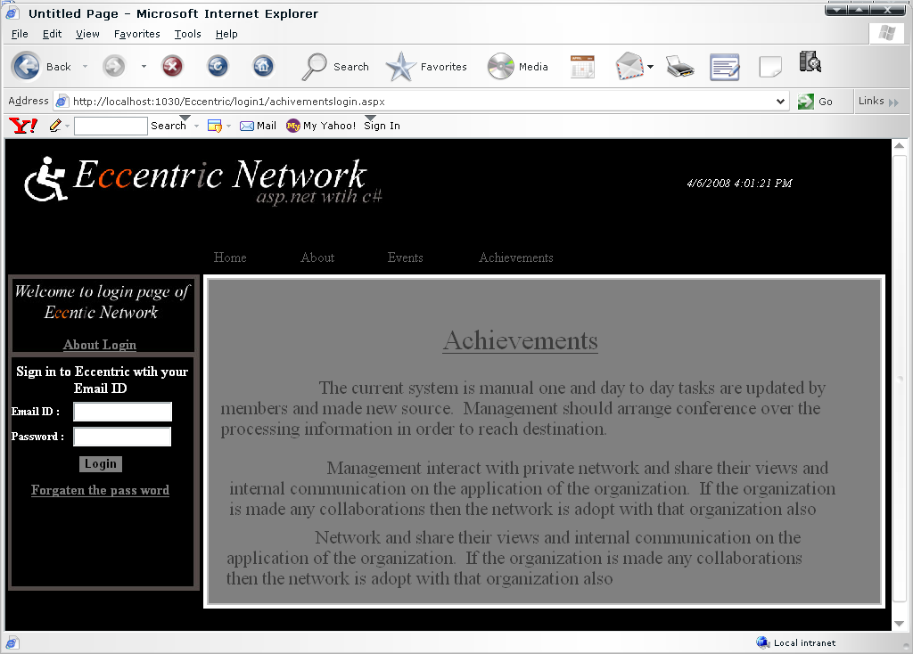
Fig (7.1.3):- It shows the Achievements of Eccentric Network

Fig (7.1.4):- It shows login Information of Eccentric Network

Fig (7.1.5):- It helps us to find a Pass word of Eccentric Network

Fig (7.2):- It shows the work space of Eccentric Network

Fig(7.3):- It shows the total people of Eccentric Network

Fig (7.3):- It shows News in Eccentric Network

Fig (7.3.1):- It shows the Creation of News in Eccentric Network

Fig (7.4):- It shows the Forums of Eccentric Network

Fig (7.4.1):- It shows the Creation of Forums in Eccentric Network

Fig (7.5):- It shows the Details of use in Eccentric Network

Fig (7.6):- It shows the About of Administrator work in Eccentric Network

Fig (7.7):- It shows the Project info of Eccentric Network

Fig (7.7.1):- It shows the Creation of Project details Eccentric Network

Fig (7.8):- It shows the Clients Info Eccentric Network

Fig (7.8.1):- It shows the Creation of Client Eccentric Network

Fig (7.9):- It shows the Employees Info Eccentric Network

Fig (7.9.1):- It shows the Employee Creation in Eccentric Network

Fig (7.10):- It shows the Compose box of Eccentric Network

Fig (7.11):- It shows the Inbox of the login member in Eccentric Network

Fig (7.12):- It shows the Sent Items of the login member in Eccentric Network

Fig (7.13):- It shows the Inbox or Sent Items message of login member in Eccentric Network

CHAPTER 8

BIBLIOGRAPHY

BOOKS REFERRED:

  - Roger.S.Pressman, Software Engineering. Mc.Graw Hill,
  - Apress.Beginning. ASP.NET.2.0.in.C.Sharp.2005. Novice.to.Professional, Jan 2006
  - Karumanchi Narayana Rao, Introduction to Microsoft .net.
  - Database Management System. Raghu Ramakrishnan, Johannes Gehrke, Mc Graw Hill. II edition.

WEB SITES REFERRED:
http://msdn.microsoft.com/net/
http://p2pwrox.com/
http://www.asp.net/
http://www.dotnet101.com
http://www.aspin.com/
http://www.dotnet-fr.org/

